Create Object
test.syn();method is mainly used to wait and avoid the console program from automatically ending after execution.
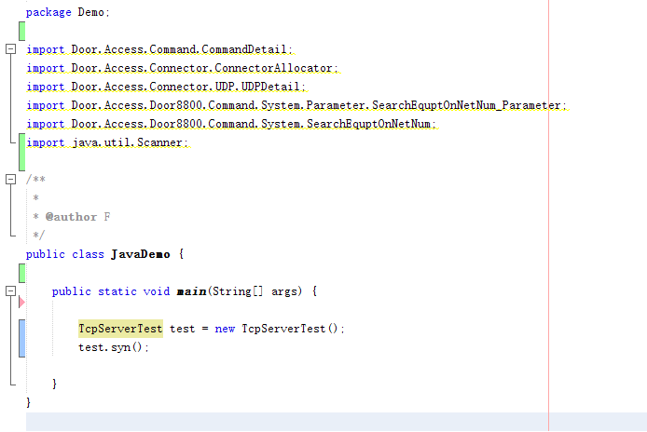

Bind Listener
In the constructor of TcpServerTest, bind the listening port mainly for listening to TCP messages.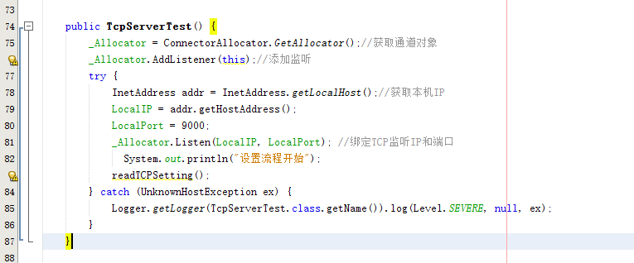

Set Control Board TCP/IP Parameters
Before setting TCP/IP parameters, you need to obtain them first and modify them based on the original parameters (it is not recommended to write them directly).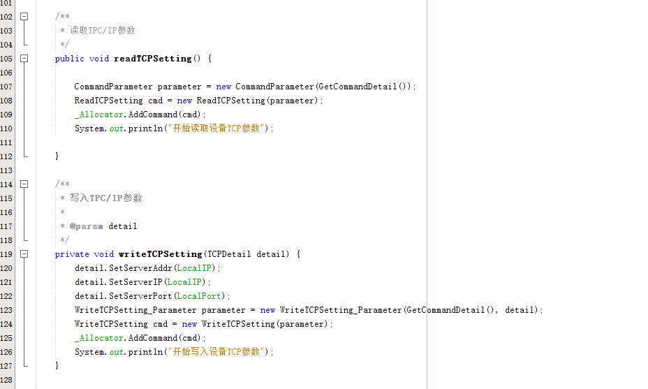

Open Device Monitoring
Using TCPSERVER mode to enable device monitoring is one of the necessary conditions.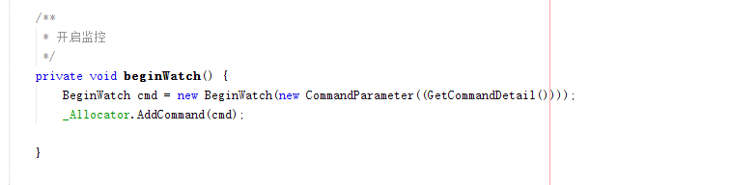

Set Device Keep-Alive Interval
Using TCPSERVER mode to enable device monitoring is one of the necessary conditions.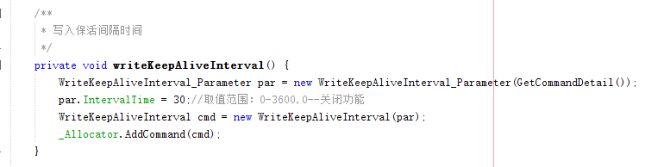

Wait for Device Connection and Send Command
After the parameter settings above are completed, you need to wait for the device to connect to the system. When the device connects to the system, it will first return to the ClientOnline event, and then return all real-time messages in the WatchEvent event. When the device connects for the first time, you need to verify the identity of the device and add a parser. For detailed calling methods, please refer to the sample code.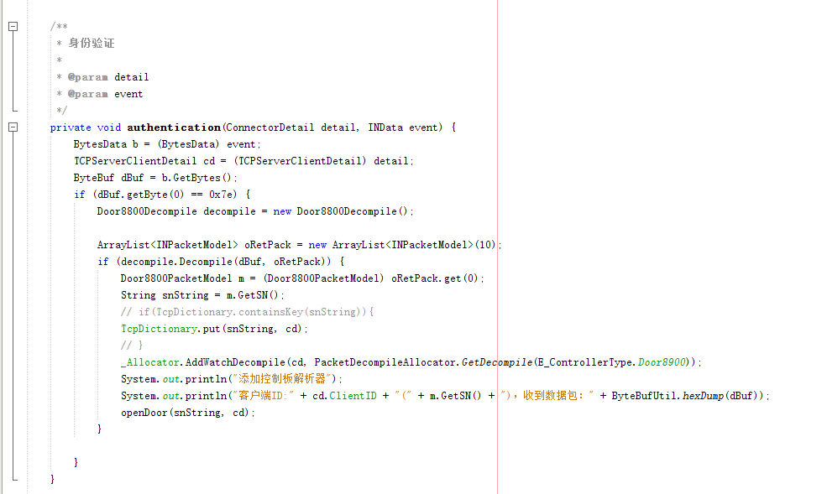
Note: When the device connects to the system, you need to save the connection parameters of the docked device, which need to be attached when sending commands later. For example, the door opening command: